**JS22-1 – Flutter Qualification**

Flutter App Theme : KicksAvenue

1. ***Login Page***

* Graphical user interface, text

  Description automatically generatedGraphical user interface, text, application

  Description automatically generatedKickAvenue Logo
* Username and password TextField
* TextField validations and display error messages.

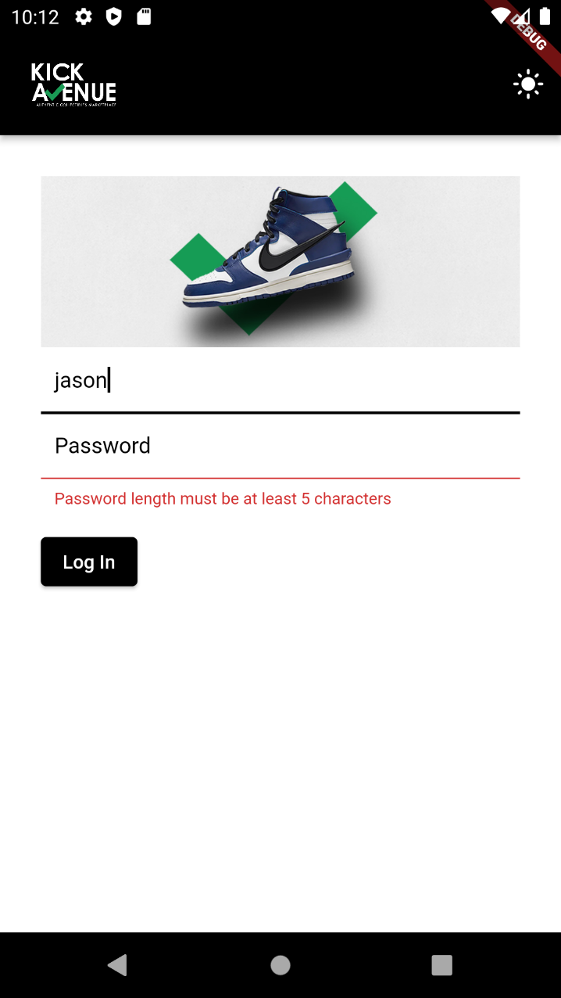

1. ***Home Page***

* Navigation Bar
* Appbar
* Display logged username
* Change theme
* Image carousel
* Infographics
* Log out

1. ***Market Page***

* Display list of shoes in the KickAvenue market
* Redirect to detail page when clicked on each items

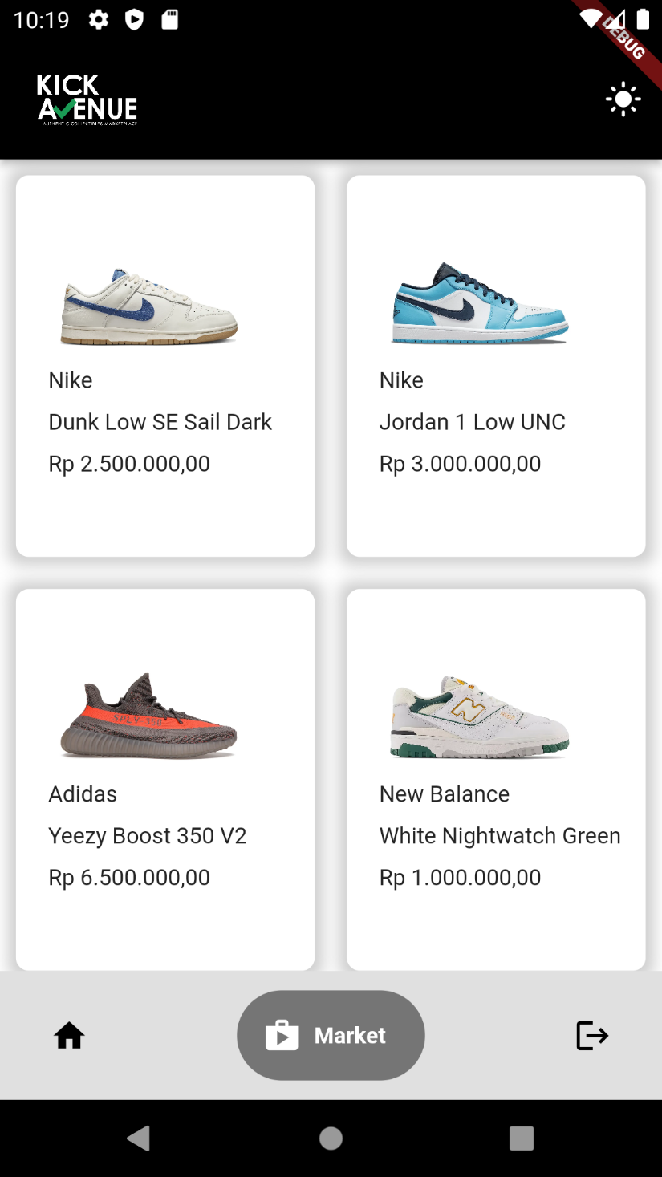

1. ***Detail Page***

* First tab display image, brand, name, price, and comment textfield.
* Display snackbar when review text field is empty.
* Text

  Description automatically generatedA picture containing text

  Description automatically generatedSecond tab display comments on shoe details.

1. Graphical user interface

   Description automatically generatedTimeline

   Description automatically generatedDark Theme Examples

